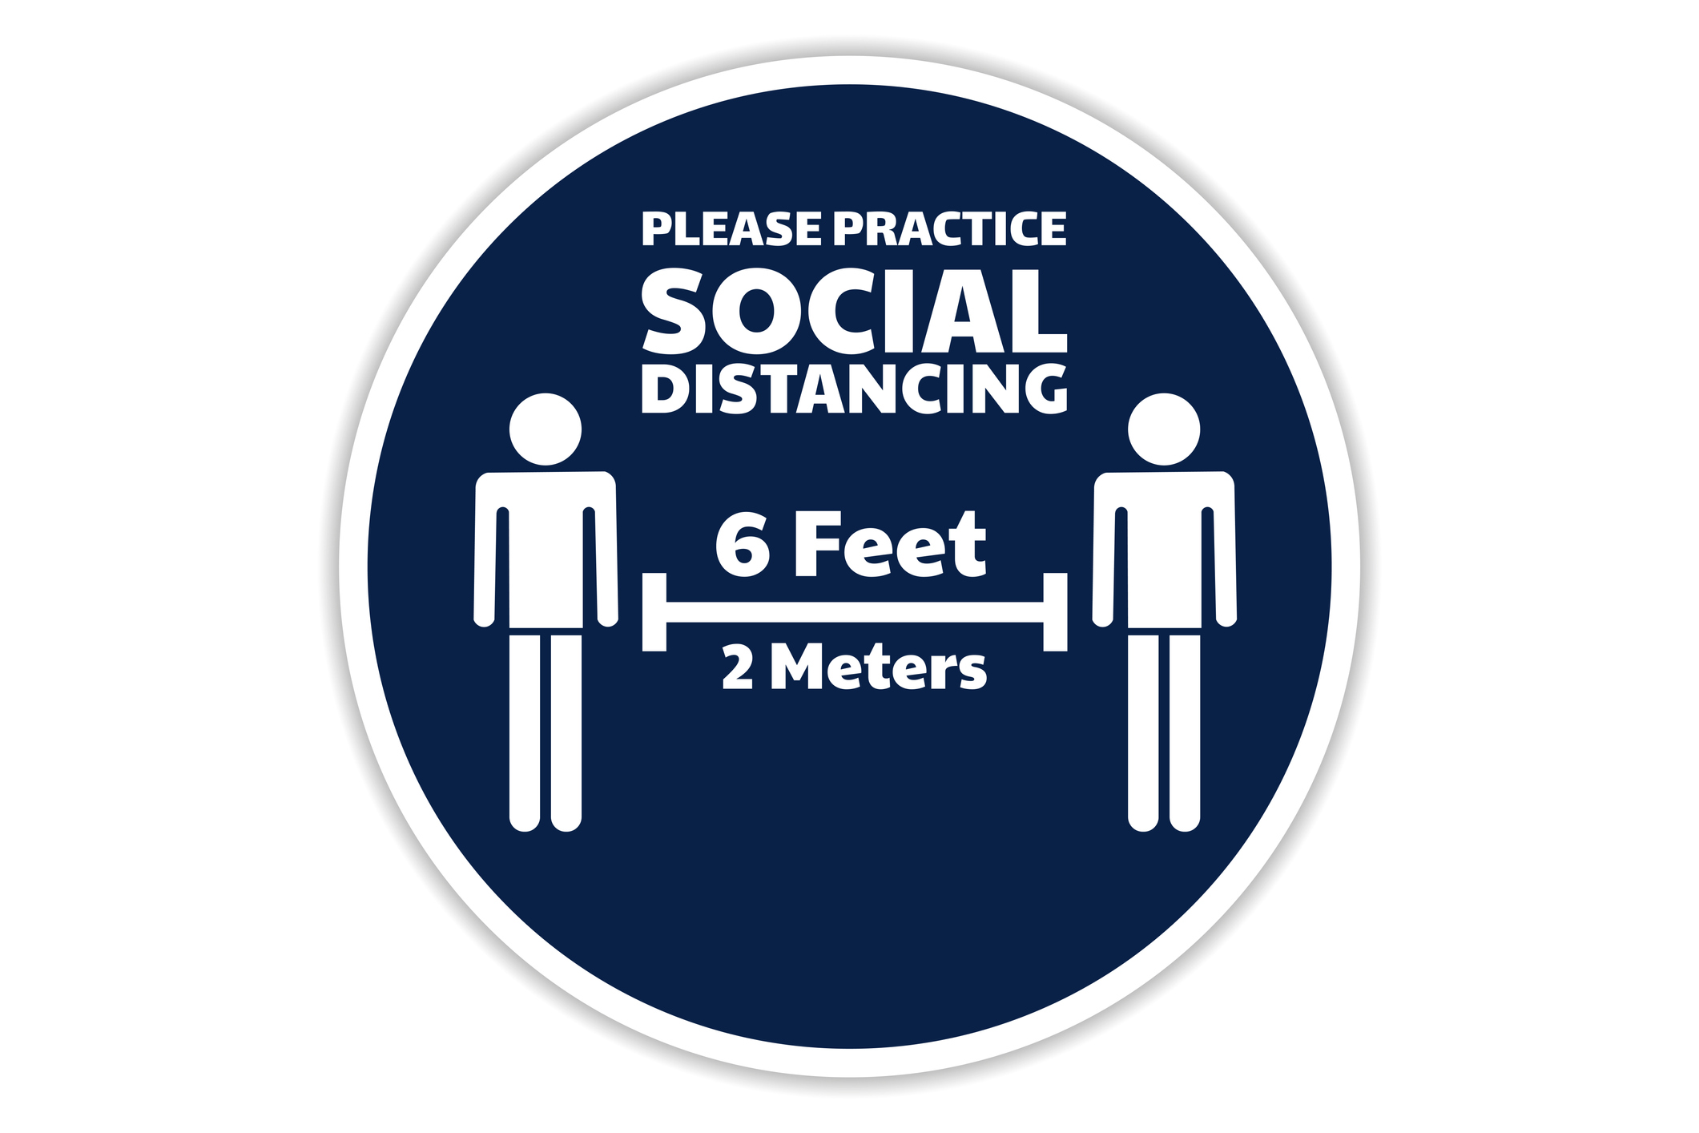

Social distancing means keeping

**6 feet apart** from others

Please keep your social distance.